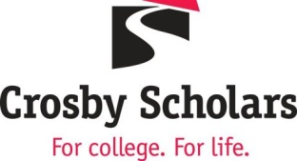
FOR IMMEDIATE RELEASE
Contact: AMANDA MATHIS
amathis@crosbyscholars.org
P: (336)725-5371

CROSBY SCHOLARS COMMUNITY PARTNERSHIP ANNOUCES OPEN APPLICATON
Winston-Salem, NC (August 15, 2019) – The Crosby Scholars Community Partnership wants to help students further their education as preparation for college starts early. Our application for enrollment is open for students in grades 6-10 through October 1, 2019.

Crosby Scholars provides students with academic and personal workshops, college admission and financial aid sessions, opportunities to visit college campuses, advisors for high school students and "Last Dollar" scholarships to graduating seniors and college students based on unmet need. Our vision is to ensure that every public school student in Forsyth County has the opportunity to attend college or other post-secondary opportunities best suited to a student's needs, aptitudes, and dreams. We are a partnership of the Kate B. Reynolds Charitable Trust, the United Way of Forsyth County, the Winston-Salem/Forsyth County Schools, and The Winston-Salem Foundation and an affiliate of Goodwill of NWNC.

With a 27-year history, Crosby Scholars now serves over 11,600 students per year. This year, the program is awarding more than $825,000 in last dollar grants. Our class of 2019 included 1,010 high school graduates who plan to attend over 141 colleges and universities. Crosby Scholars performed more than 97,000 hours of community service for the 2018-2019 academic year. To learn more about the Crosby Scholars Program and to apply, visit www.crosbyscholars.org or call 336-725-5371.

###

